PIZZA SALES SQL QUERIES

- KPI’s
1.Total Revenue
select sum(total_price) as Total_Revenue from pizza_sales
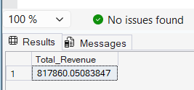

2. Average order value
select sum(total_price)/count(distinct order_id) as Avg_Order_Value from pizza_sales;
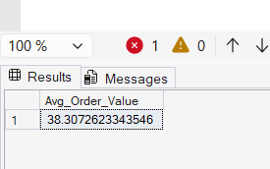

3.Total pizzas sold
select sum(quantity) as Total_Pizza_Sold from pizza_sales
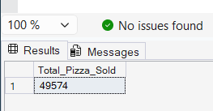

4.Total orders
select count(distinct order_id) as Total_orders from pizza_sales
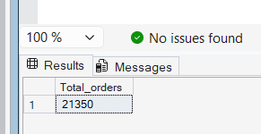
5.Average pizzas per order

select cast(cast(sum(quantity) as Decimal (10,2))/
cast(count(distinct order_id) as decimal(10,2)) as decimal(10,2)) as Avg_pizzas_per_order from pizza_sales
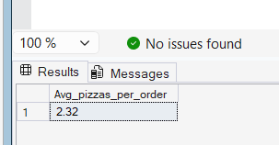

- Daily trend for total orders

select DATENAME(DW,order_date) as order_day, count(distinct order_id) as Total_orders
from pizza_sales
group by DATENAME(DW,order_date)
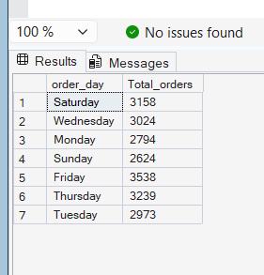

- Monthly trend for total orders
select datename(month, order_date) as Month_Name, count(distinct order_id) as Total_orders
from pizza_sales
group by datename(month, order_date)
order by Total_orders desc

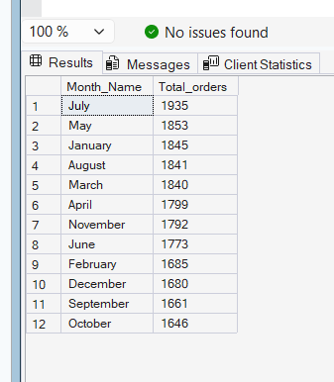

- Percentage of sales by pizza category

select pizza_category,
sum(total_price) * 100 / (select sum(total_price) from pizza_sales) as Total_Sales
from pizza_sales
group by pizza_category;

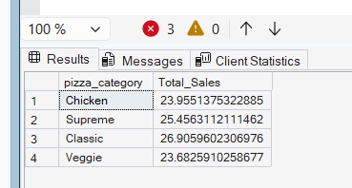

- Percentage of sales by pizza size

select pizza_size, sum(total_price) as Total_sales, sum(total_price)*100/
(select sum(total_price) from pizza_sales) as PCT
from pizza_sales
group by pizza_size
order by PCT
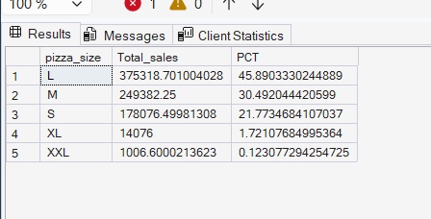

- Top 5 best sellers

use [Pizza DB];

select top 5 pizza_name, sum(total_price) as Total_Revenue from pizza_sales
group by pizza_name
order by Total_Revenue desc

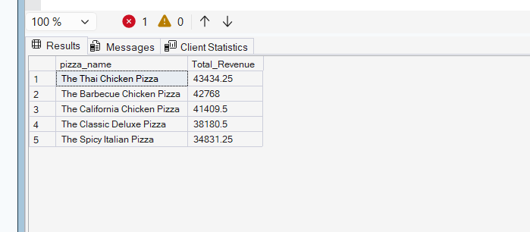

Bottom 5 sellers

use [Pizza DB];

select top 5 pizza_name, sum(total_price) as Total_Revenue from pizza_sales
group by pizza_name
order by Total_Revenue asc

